ProjectTitle:

### A CRM Application to Manage the Services offered by an Institution

# ProjectOverview

To design and develop a Customer Relationship Management (CRM) application tailored for an institution's service offerings, leveraging Salesforce's robust ecosystem. The application will enhance the management of services, improve client interactions, streamline processes, and ensure scalability as the institution grows

.

# Objectives

To develop a robust CRM application that simplifies the management of the institution's service offerings, ensuring efficient processes, real-time updates, and seamless coordination across departments.

To improve client interactions and satisfaction through personalized services, data-driven insights, and automated workflows, ultimately driving increased client retention and revenue growth

# SalesforceKeyFeaturesandConceptsUtilized

#### ****1. Salesforce Lightning Experience****

* **Modern UI:** Utilizes Lightning Web Components (LWC) for an intuitive, responsive, and efficient user interface.
* **Customization:** Allows drag-and-drop configuration, enabling quick customization for evolving business needs.

#### ****2. Salesforce Einstein AI****

* **Predictive Insights:** Leverages Salesforce Einstein to predict client behavior and service trends.
* **Automation:** Automates lead scoring, next-best-action recommendations, and service suggestions to enhance productivity.

#### ****3. Salesforce Flow and Process Automation****

* **Automated Workflows:** Automates repetitive processes like service assignments, notifications, and escalations.
* **Efficiency:** Reduces manual intervention through declarative automation tools like Flows and Process Builder.
* **Flexibility:** Supports rapid adaptation to changing workflows without extensive code changes.

#### ****4. Integration with Salesforce AppExchange****

* **Third-Party Integrations:** Seamlessly integrates with third-party applications for marketing, payment, and communication.
* **Pre-Built Solutions:** Leverages AppExchange solutions to reduce development time and costs.

#### ****5. Scalability and Cloud Advantage****

* **Scalability:** Salesforce’s multi-tenant architecture ensures the CRM scales as the institution grows.
* **Global Access:** Cloud-based deployment ensures global accessibility with secure data storage.

#### ****6. Mobile-First Strategy****

* **Salesforce Mobile App:** Provides on-the-go access to client data, service catalogs, and dashboards.
* **Responsive Design:** Ensures seamless usability across devices, empowering a remote workforce.

#### ****7. Data Security and Compliance****

* **Salesforce Shield:** Ensures data encryption, event monitoring, and field-level security for sensitive information.
* **Compliance:** Aligns with GDPR, HIPAA, and other global regulatory standards.

#### ****8. Collaboration with Slack Integration****

* **Team Collaboration:** Enables real-time communication and collaboration through Slack integration.
* **Improved Productivity:** Centralizes updates, tasks, and workflows for better team coordination.

#### ****9. API-Driven Architecture****

* **Custom Integrations:** Uses REST and SOAP APIs to connect the CRM with legacy systems or external platforms.
* **Flexibility:** Supports microservices-based integrations for modular and agile application development.

# DetailedStepstoSolutionDesign

**Requirement Analysis**: Identify functional and non-functional needs, focusing on customer, service, and sales management.

**System Architecture**: Plan frontend, backend, database, and integration layers for scalability and modularity.

**Data Model Design**: Define entities (e.g., customers, services, leads) and their relationships for efficient data handling.

**Feature Specification**: Detail core functionalities like customer profiles, service catalogs, communication tools, and analytics dashboards.

**UI/UX Design**: Create responsive, intuitive interfaces for users and a customer portal for self-service.

**Technology Stack**: Select robust technologies for frontend (React, Vue.js), backend (Node.js, Django), and hosting (AWS, Azure).

**Development and Testing**: Build and test in phases, ensuring seamless integration, security, and performance.

**Deployment**: Host on a cloud platform with CI/CD pipelines and performance monitoring.

**Training**: Provide documentation and role-specific training for users.

**Support & Maintenance**: Monitor performance, collect feedback, and release updates for continuous improvement..

# TestingandValidation

### ****1. Types of Testing****

#### ****a. Unit Testing****

* Validate individual components (e.g., lead tracking, service management).
* Ensure functions like data entry, form validation, and API calls work correctly.

#### ****b. Integration Testing****

* Test how different modules (e.g., customer profiles, sales pipeline, reporting) interact.
* Verify integrations with external tools like email/SMS systems and payment gateways.

#### ****c. Functional Testing****

* Check the application against business requirements.
* Ensure workflows, like lead conversion and opportunity tracking, function as expected.

#### ****d. Performance Testing****

* Measure response times under normal and peak loads.
* Identify bottlenecks in handling large customer and service datasets.

#### ****e. Security Testing****

* Validate data encryption, role-based access, and protection against vulnerabilities like SQL injection and unauthorized access.

#### ****f. User Acceptance Testing (UAT)****

* Involve end-users (sales representatives and managers) to confirm the system meets their needs.

# KeyScenariosAddressedbySalesforceinthe Implementation Project

### ****1. Customer Onboarding and Management****

* Enable the sales team to capture, store, and manage customer data in a centralized repository.
* Facilitate segmentation and personalized engagement through detailed customer profiling.

### ****2. Lead Tracking and Opportunity Management****

* Automate lead capture from multiple channels (e.g., email, website, social media).
* Track the lead lifecycle, convert qualified leads into opportunities, and monitor progress through sales stages.

### ****3. Service Catalog and Scheduling****

* Provide a detailed catalog of services with pricing, descriptions, and availability.
* Enable scheduling and tracking of services, ensuring timely delivery and follow-ups.

### ****4. Communication and Collaboration****

* Integrate communication tools (e.g., email, SMS) for timely customer engagement.
* Foster collaboration among sales team members with features like task assignments and shared notes.

### ****5. Analytics and Reporting****

* Deliver real-time insights through dashboards, including KPIs like sales performance, conversion rates, and revenue forecasts.
* Generate custom reports for leadership and operational decision-making.

### ****6. Workflow Automation****

* Automate repetitive tasks, such as sending follow-up emails, scheduling reminders, and updating statuses.
* Free up the sales team to focus on high-value activities.

### ****7. Integration with Third-Party Systems****

* Seamlessly integrate with tools like payment gateways, marketing platforms, and customer service software.
* Ensure a unified ecosystem for better data consistency and operational efficiency.

### ****8. Customer Self-Service Portal****

* Provide customers with a platform to book services, track statuses, and submit feedback.
* Empower customers while reducing the burden on the sales and service teams.

### ****9. Compliance and Security****

* Ensure data handling complies with legal and regulatory requirements (e.g., GDPR).
* Provide role-based access to safeguard sensitive information.

### ****10. Scalability for Future Growth****

* Implement features that can scale with the institution’s expanding customer base and service portfolio.
* Support customization for evolving business needs.

By addressing these scenarios, Salesforce helps optimize service delivery, improve customer satisfaction, and empower the sales force to achieve better outcomes.

**OUTPUT:**

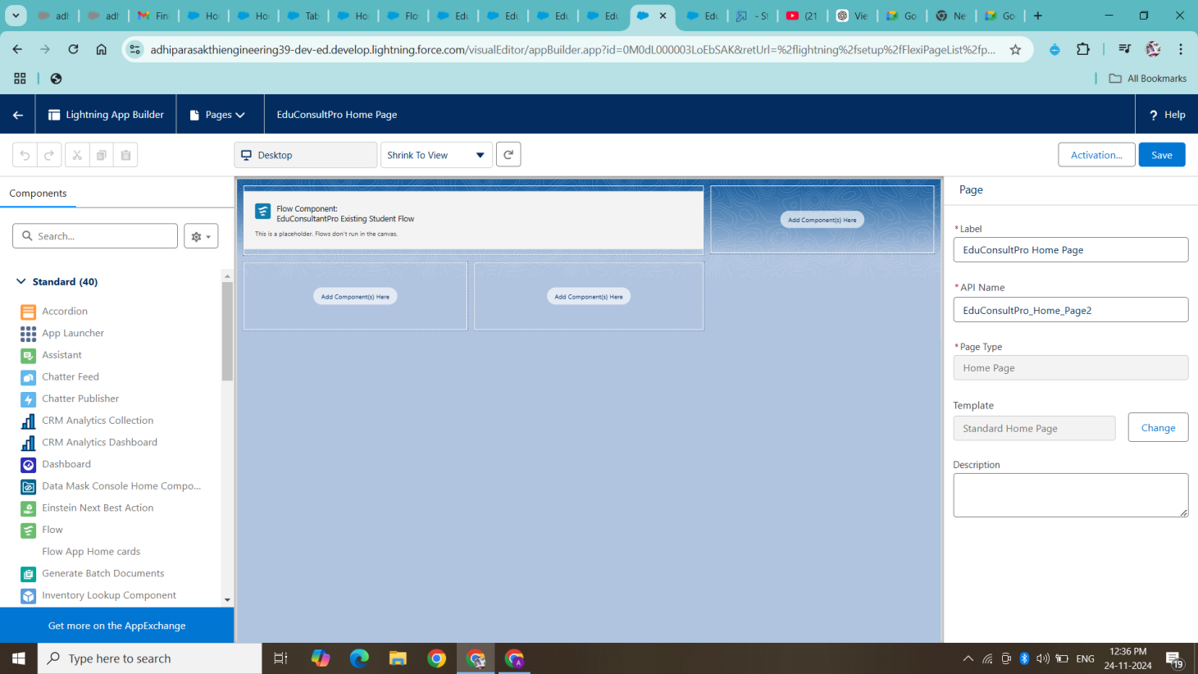

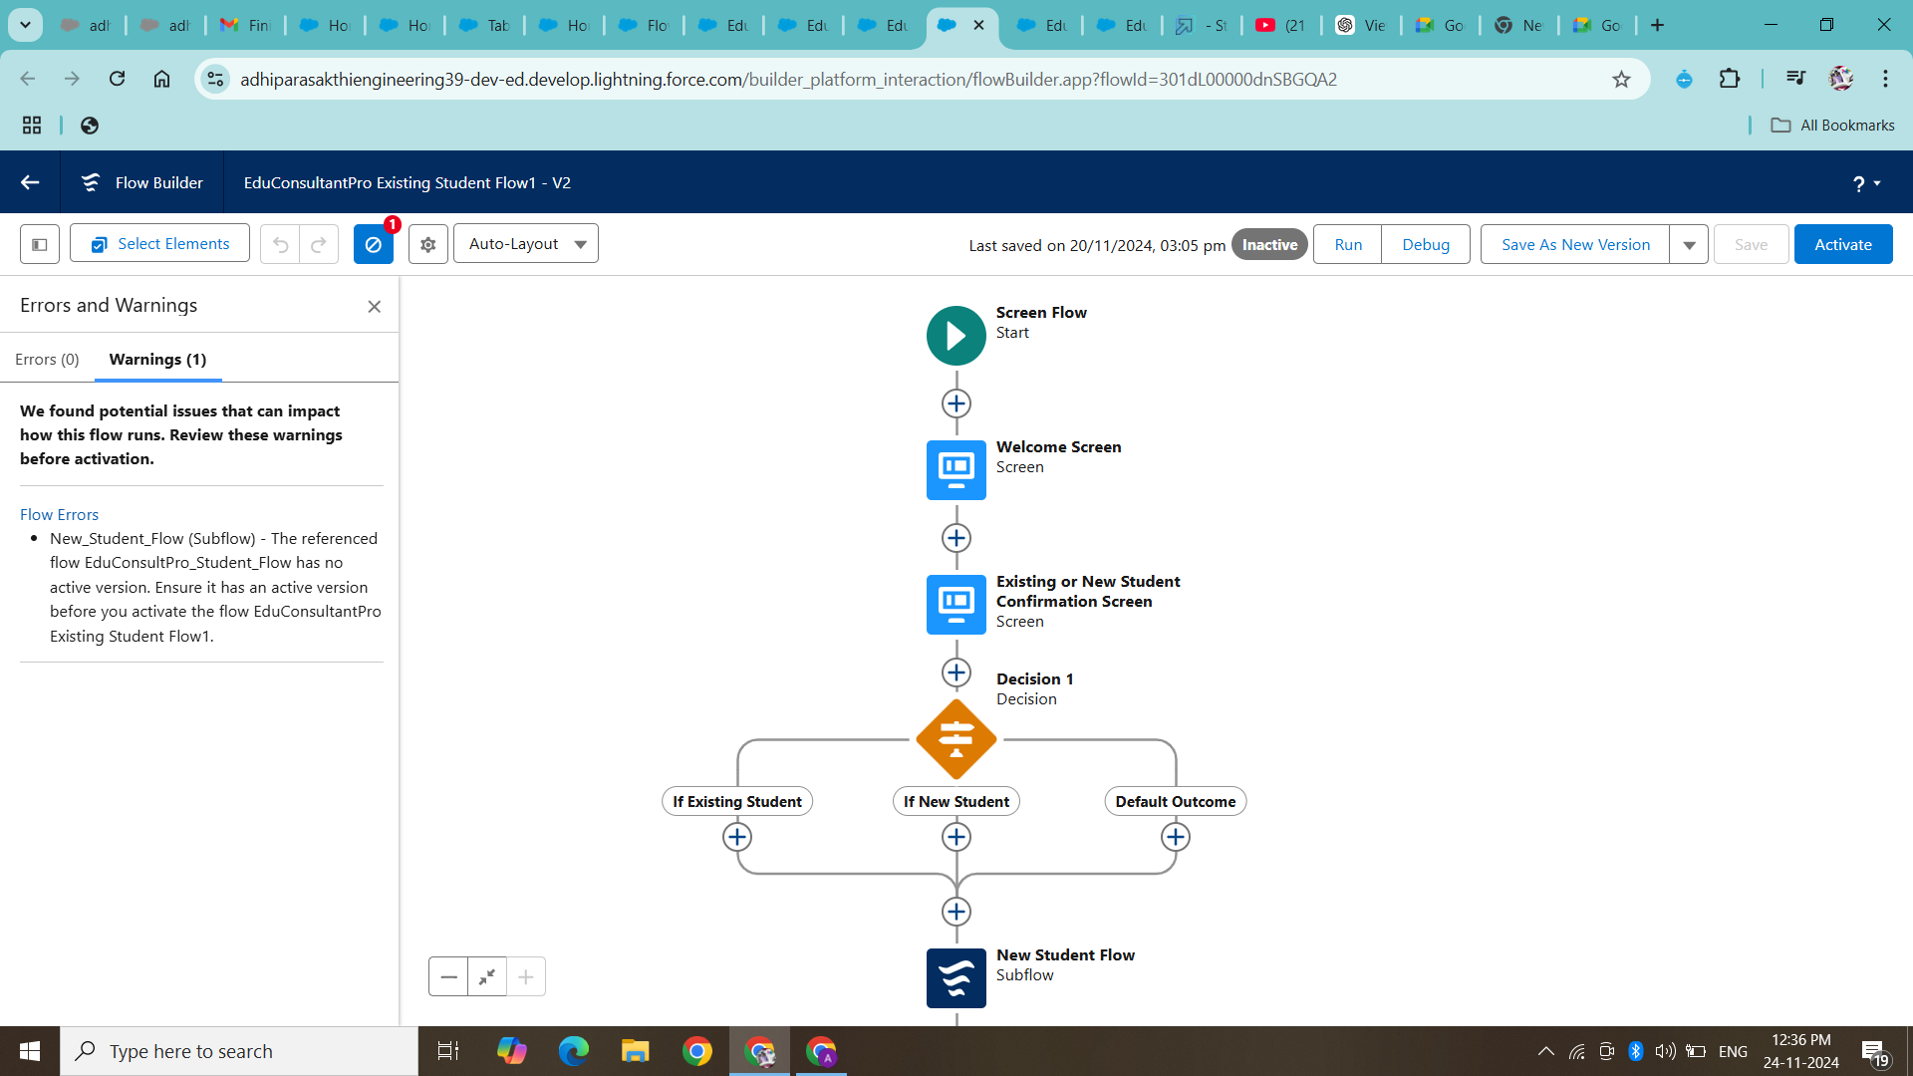

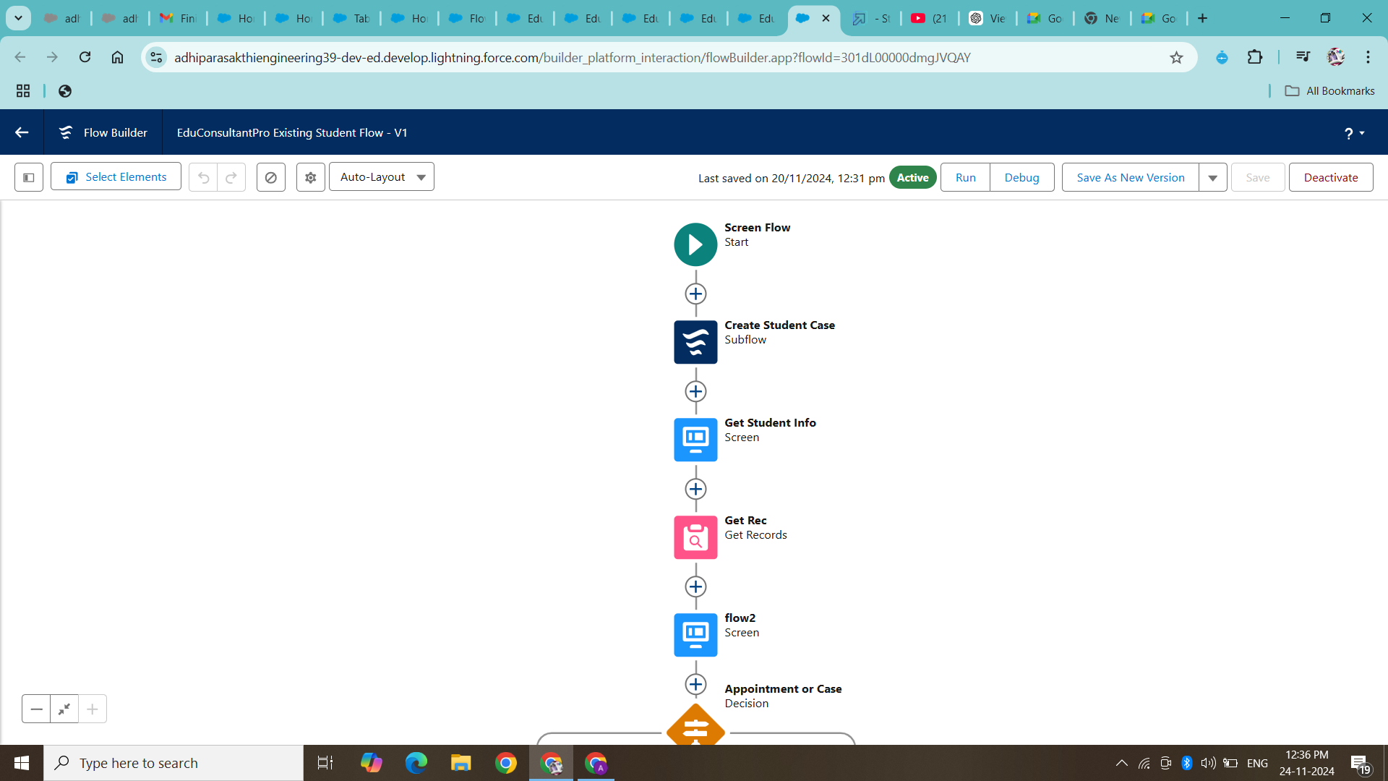

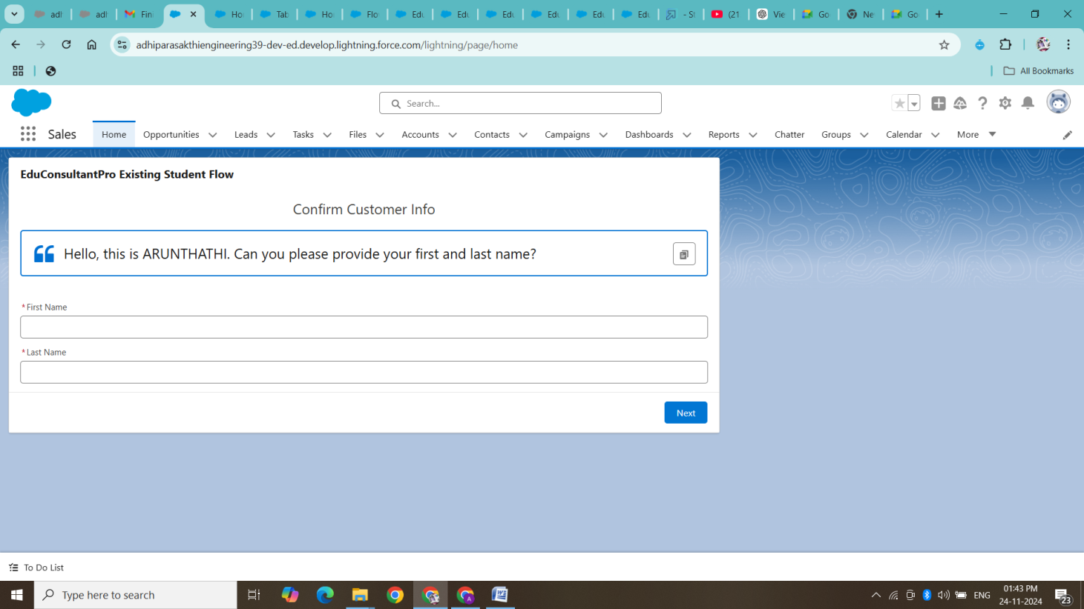

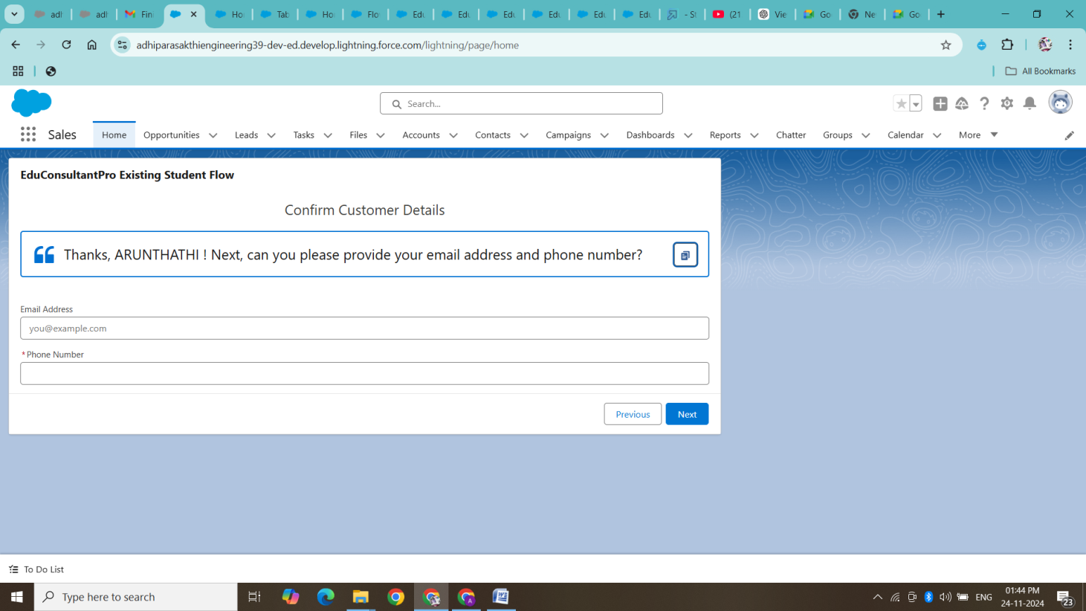

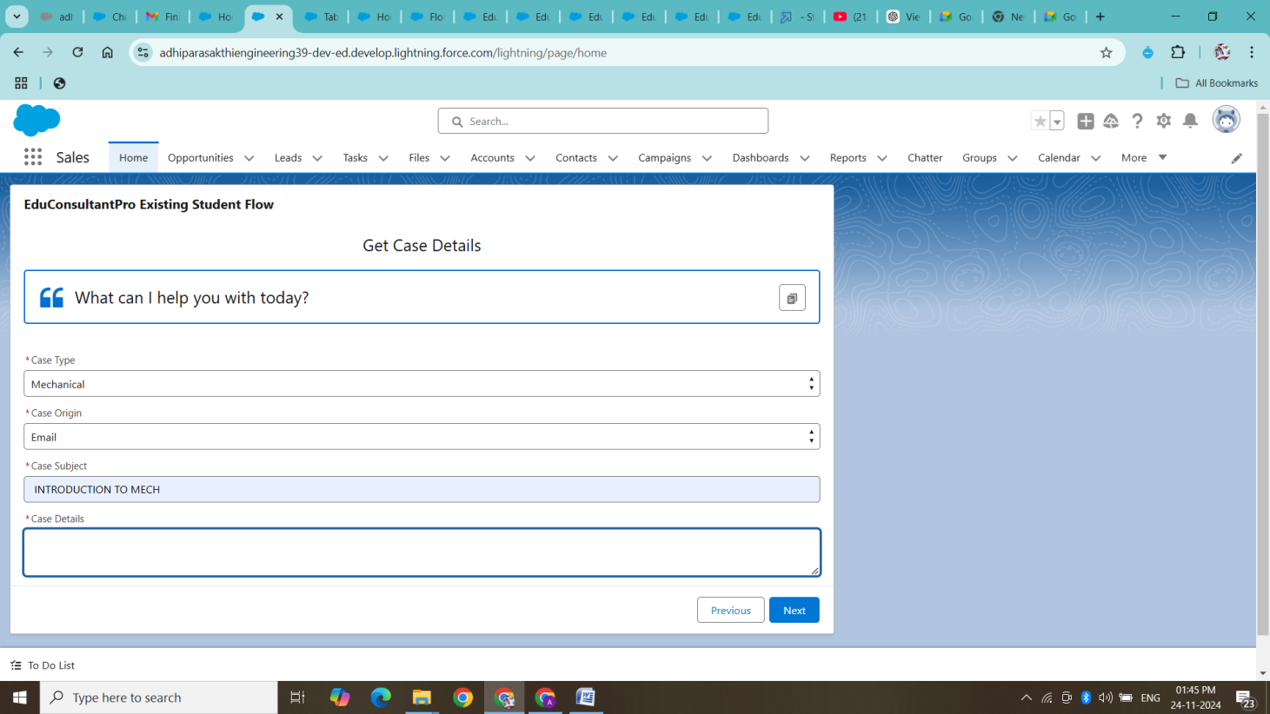

# Conclusion

The implementation of a CRM application powered by Salesforce to manage the services offered by an institution has significantly streamlined operations and enhanced the sales force’s effectiveness. By addressing key scenarios such as customer onboarding, lead tracking, service catalog management, and workflow automation, the institution has created a unified, efficient system that not only improves customer relationships but also drives sales performance.

Salesforce's integration of communication tools, real-time analytics, and seamless third-party system connections has empowered the sales team with actionable insights and automated processes, allowing them to focus on high-value tasks. The customer self-service portal has further enhanced engagement by giving clients the ability to manage their interactions independently.

Additionally, the CRM ensures compliance with legal regulations, safeguards sensitive data with robust security measures, and provides scalability to accommodate future growth. Ultimately, the CRM implementation has delivered a comprehensive solution that improves both internal workflows and customer experiences, driving long-term business success and institutional growth.

This project has not only enhanced operational efficiency but also laid the foundation for continuous improvement, adapting to future challenges and opportunities in the institution's service offerings.